ML excerise 1

Find as algorithm:

Program:

import csv

num_attributes = 5

a = []

print("\n The Given Training Data Set \n")

with open(r'C:\Users\21ad058\Downloads\tennis.csv', 'r') as csvfile:

reader = csv.reader(csvfile)

for row in reader:

a.append (row)

print(row)

print("\n General hypothesis: ")

hypothesis = ['0'] * num_attributes

print(hypothesis)

for j in range(0,num_attributes):

hypothesis[j] = a[1][j]

print("\n specific hypothesis: ")

print(hypothesis)

print("\n Find S: Finding a Maximally Specific Hypothesis\n")

for i in range(0,len(a)):

if a[i][num_attributes]=='Yes':

for j in range(0,num_attributes):

if a[i][j]!=hypothesis[j]:

hypothesis[j]='?'

else :

hypothesis[j]= a[i][j]

print(" For Training instance No:{} the hypothesis is ".format(i), hypothesis)

print("\n The Maximally Specific Hypothesis for a given Training Examples :\n")

print(hypothesis)

Output:

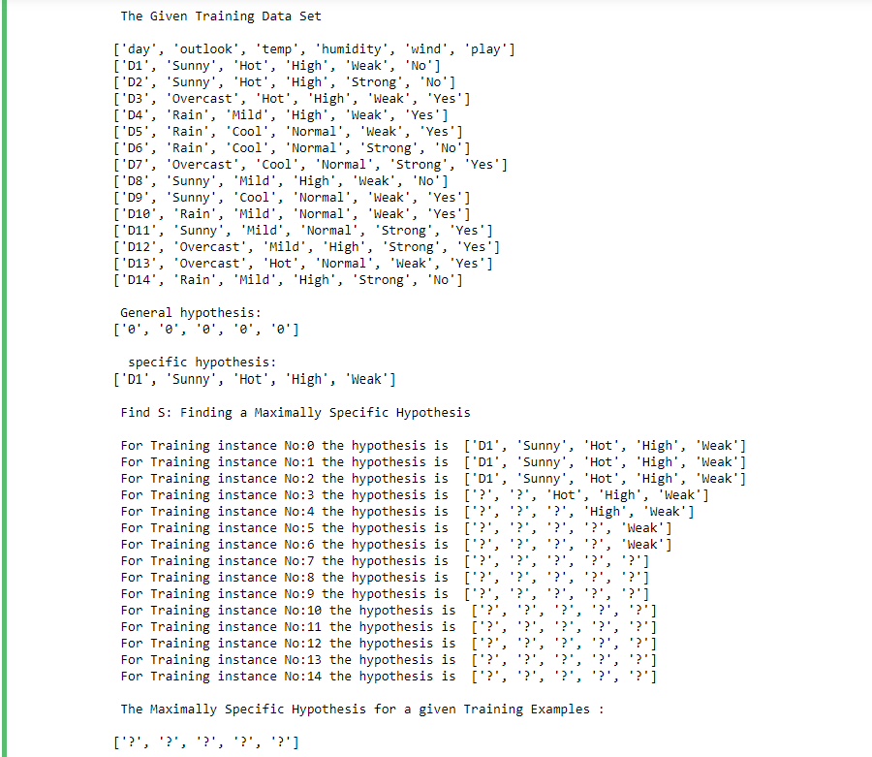

Candidate elimination algorithm

Program:

import csv

num_attributes = 5

a = []

print("\n The Given Training Data Set \n")

with open(r'C:\Users\21ad058\Downloads\tennis.csv

', 'r') as csvfile):

reader = csv.reader(csvfile)

for row in reader:

a.append(row)

print(row)

# Initial hypothesis

specific_hypothesis = ['0'] * num_attributes

general_hypothesis = ['?', '?', '?', '?', '?']

print("\n Initial specific hypothesis: ", specific_hypothesis)

print(" Initial general hypothesis: ", general_hypothesis)

# Candidate Elimination Algorithm

for i in range(0, len(a)):

if a[i][num_attributes] == 'Yes':

for j in range(0, num_attributes):

if specific_hypothesis[j] == '0':

specific_hypothesis[j] = a[i][j]

elif specific_hypothesis[j] != a[i][j]:

specific_hypothesis[j] = '?'

general_hypothesis[j] = '?'

else:

for j in range(0, num_attributes):

if specific_hypothesis[j] == a[i][j]:

specific_hypothesis[j] = '?'

# Update general hypothesis

for j in range(0, num_attributes):

if specific_hypothesis[j] != '?':

general_hypothesis[j] = specific_hypothesis[j]

print("\n For Training instance No:{} the specific hypothesis is: ".format(i), specific_hypothesis)

print(" For Training instance No:{} the general hypothesis is: ".format(i), general_hypothesis)

print("\n Final specific hypothesis: ", specific_hypothesis)

print(" Final general hypothesis: ", general_hypothesis)

output:

